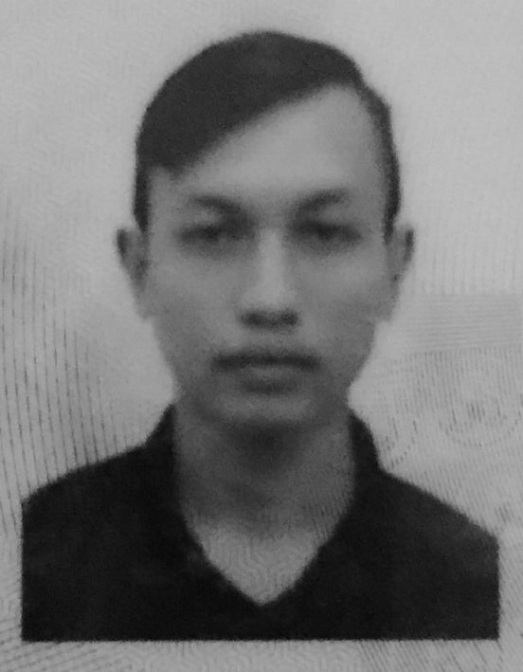
PERSONAL PARTICULARS

NAME : MOHD YUSSAIRY BIN MOHD YUSSOFF NATIONALITY : MALAYSIAN
ADDRESS : LOT 742-A KG. BARU RHU MUDA, RACE : MALAY
(GMA B 22) 21600 MARANG, RELIGION : ISLAM
TERENGGANU
NRIC : 901009-12-5829 MARITAL STATUS : SINGLE
TELEPHONE : 017 – 220 9020 DATE OF BIRTH : 9 OCTOBER 1990
EMAIL : kucai_tenshou@yahoo.com
ACADEMIC QUALIFICATION

2009 : SIJIL KEMAHIRAN MALAYSIA (LEVEL 2 & 3) - MECHATRONICS
2007 : SPM- SMK LUNDU

LANGUAGE PROFICIENCY

LANGUAGE | WRITTEN | SPOKEN
MALAY | EXCELLENT | EXCELLENT
ENGLISH | AVERAGE | AVERAGE

SKILLS

COMPUTER : 1) WINDOWS
2) MICROSOFT OFFICE (WORDS, POWER POINT, EXCEL)

CAREER OBJECTIVE

It has been a pleasant to tell you that I am interest to apply for an engineer or any applicable job that is suitable with my qualification. Right now I work as sales advisor at Edaran Tan Chong Motor (Utara) Sdn. Bhd. and now I am looking forward for a new job new experience and new challenging working environment in order to increase my skills and knowledge.

WORKING EXPERIENCE

- Pro Direct Sdn. Bhd. (Kuching, Sarawak) – 4 months
  - Maxis Dealer – monitoring sales per day & give training to new crew.
  - Position: Sales Supervisor

- Aeon Credit Services (M) Sdn. Bhd (Kuching, Sarawak) – 2 years
  - Process customer loan.
  - Mainly in-charge on General Easy Payment (GEP)
  - Position : Clerk (C20)

- Edaran Tan Chong Motor (Utara) Sdn. Bhd. – CURRENT
- Sales Advisor

PERSONAL STRENGTH

- Can communicate well with customer
- Can work under pressure
- Fast learner and can give full commitment during work in group
- Good team player, self-motivated and able to work independently

REFERENCES

- Name : Chia Siaw Ping
Position: Team Leader General Easy Payment (GEP)
Aeon Credit Services (M) Sdn. Bhd.
Tel : 082 - 223388
Email : spchia@aeonmalaysia.com.my

- Name : Noramurni Binti Ramli
Position: Sales Manager
Edaran Tan Chong Motor (Utara) Sdn. Bhd.
Tel : 09 - 622 2349
Fax : 09 – 622 3849
Email : etcmktt@tanchonggroup.com

